Project 1
< Number Mind>

CSC-11 (48982)
Name: Menon, Deepak
Date: 11/8/2015

Introduction

Title: Number Mind

“Number Mind” is a number guessing game in which the player must guess the number the computer is hiding from the player. The basics of the game is that there are two dices being played at random and the sum of the dice will be kept hidden from the player. The player will have to guess the dice number each turn correctly for a turn of 4 to win the game. This is the first version of the game and the second version will implement more turns and also better odds of winning.

Summary

Number of lines (C++): 105

The C++ version of the code contains 105 lines of code including all the header files and the libraries. There are 6 variables used in the program. The program starts with creating a random number sequence in the program. The user has to then guess and input a number from 1 to 12. He has to do this 4 times. Each time the number is compared to the original random number. If it matches then he will win the game. Making the code in C++ was the easy part, but the tricky part was converting the code from C++ to Assembly. The original concept was to make a Mastermind game. I later decided to make a number guessing game instead. The assembly part of the game uses the random number generator shown by Dr. Lehr in class. It also uses the divmod file for the remainders. In the assembly program I have implemented conditional branches, register manipulation, scanf, printf, shift left and right, addition and subtraction.

Description

Pseudo Code
Start program
Greeting message
Generate random numbers for the 4 numbers
Instructions for user
Branch to the header file
Start loop
Get input number from user
If user enter higher than random number the tell user of the high number
Else if number is lower than random number tell the user that number is low
Else if number is the same as random number then return status as 1
Returns to main program
If status is equal to 4 player wins
Else Player looses
Game exits

Flowchart

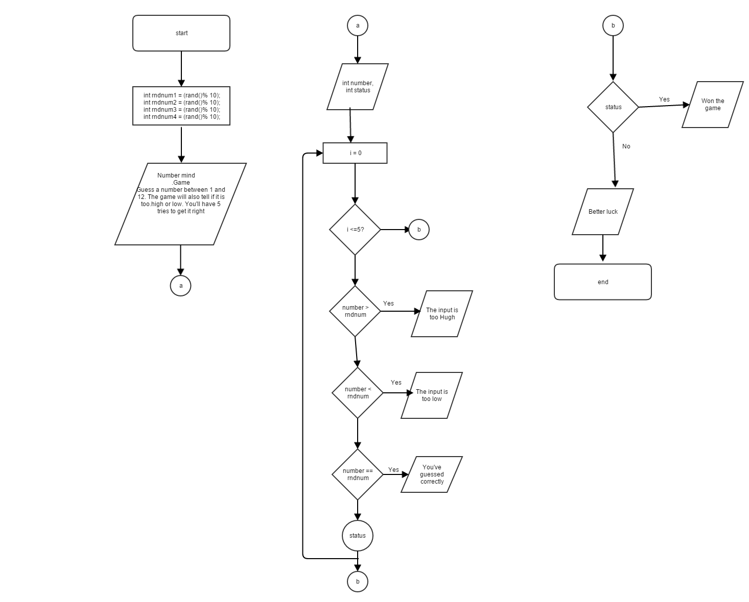
Language Constructs

Assembly constructs like MOV, LDR, BL have been used throughout
the program. Also, other things used in the program include printf and scanf for input and output manipulation. Other concepts that were interesting are the STR and branching for moving things into memory address to manipulate them later in the program. There are also uses of random functions and divmod in the program.

Work References

The mainDivModFuncV2.s and randTest.s have been used in the program from the topics that were presented in class for the random number generator.

